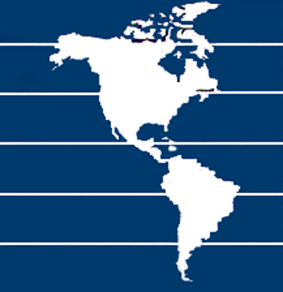
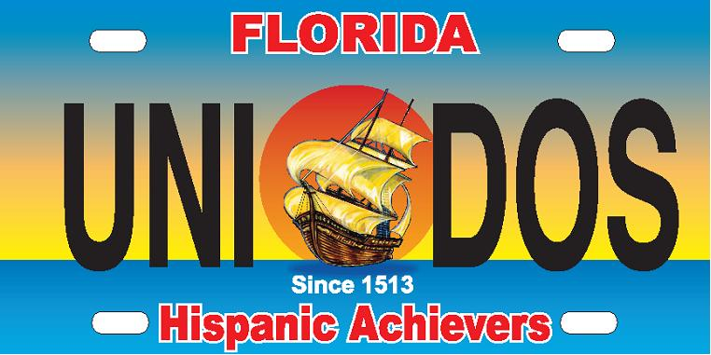
NATIONAL HISPANIC CORPORATE ACHIEVERS, INC.

28th YEAR EDUCATIONAL FOUNDATION, NOT FOR PROFIT ORGANIZATION 501(3)(C)

Operating Committee  Daniel Ramos  Chairman and CEO  National Hispanic Corporate Achievers  Philip Berry  President, NHCA - U. S. North  President, Philip Berry Associates  Vice Chair, City University of NY  Jay Rosario  President, NHCA - U. S. South  Business Owner – Rosario Auto Group  Eugene Kelly, Worldwide Director Global Workplace Initiatives  Colgate-Palmolive  Alexandra Contreras, Senior Analyst Global Workplace Initiatives  Colgate-Palmolive  Melba Cruz Vasti  Former Assistant VP, International  Compensation & Benefits, HR  MetLife  Irene Rivera  Operating Board Second President  Principal Advisor, Inclusion & Diversity, National Grid  Angelica Wong, VP Operations Leader  Emergining Markets  Pfizer, Inc.  María-Dolores Vázquez-Abad  Senior Director, WWD  Pfizer R&D  Maria Guazzaroni Jacobs, Ph.D.  Director Quality and Regulatory Policy (QRP), Pfizer, Inc.  Denise Singleton  CEO & President  ThrivePROS Consulting  Dr. Angela Anselmo  Director SEEK Program  Baruch College, CUNY  Jennifer Salas  Enrollment Services Coordinator  Baruch College, CUNY  Makini R. Brereton, Senior Analyst  Berry Block & Bernstein LLC  Carla Abonia  Exclusive Agent  AllState Life Insurance Company  Lisa M. Pietri  NHCA Executive Director  Adam Sudbury, Esq.  Legal Advisor | News Release  Contact: Danny Ramos Email: NHCA@bellsouth.net  Phone: (202) 905-3600  Premier Educational Programs and National & International Hispanic Achievers Honored during Hispanic Heritage Month  New York City, September 2, 2011 - The promotion and advancement of diversity and inclusion of Hispanic talent in Corporate America has been the main objective for the National Hispanic Corporative Achievers and its Corporate Members for the past 30 years. Our mission statement includes hiring, promoting, retaining, and highlighting Hispanic leaders and role models, while sharing knowledge and best practices between corporations through educational programs. The National Hispanic Corporate Achievers, a non-profit Organization, also provides a forum to younger Hispanic Professionals and students to further educate within the Hispanic Community by providing access to professionals in the workplace, mentoring, coaching, and scholarship grants.  Our National Organization and its Operating Committee cordially invite Corporate America to join premier educational and recognition events with the theme “Next Decade of Science, Health & Technology: New Directions, New Occupations and Innovations” during the Hispanic Heritage Month:  - Hispanic Achieves Leadership Institute  October 26th at AMA Executive Conference Center, NYC  - Empowerment Forum  October 27th at Baruch College, CUNY, Newman Conference Center  - 28th National Hispanic Corporate Achievers Global Diversity Awards Gala – October 28th at The Roosevelt Hotel in New York City. This Black Tie Award Gala is a fundraising event to provide scholarship and to recognize National Hispanic Achievers and International Hispanic Business Leaders selected by Latin America Embassies in the United States.  The National Hispanic Corporate Achievers Operating Committee is comprised by representatives of CUNY Board of Trustees and Executives of Pfizer, Colgate-Palmolive Company, MetLife, The McGraw-Hill Companies, National Grid, and with the support of FedEx and Allstate.  For more information about our Annual Program or to become a Corporate Member, please contact us at NHCA@bellsouth.net, (202) 905-3600 or visit www.HispanicAchievers.org.  # # # | Hispanic Achievers Grant Council - FL  Dennis Freytes, Chairman  L. Coronel U.S. Army (Ret.)  VP NAUS – SE Region  Lou Soto, Co-Chairman  Soto Insurance Resources  Lisa M. Pietri  Adm./Logistic Senior Dir.  NHCA Officer/Exec. Director  Dr. Sylvia Caceres  Selection & Evaluation Committee Chair  Juan de la Torre, Legal Advisor  The Law Office of Juan de la Torre, Esquire  Prof. Anthony Suarez  Legal Advisor Co-Chair  Anthony Suarez Attorney  Sandra Carrasquillo  PA/Media Director  Clear Channel News Reporter  Jacqueline Centeno  Senior Dir. Education/Training  Ana G. Mendez Univ. System  Samuel Lopez  FL Central Region Chair  Florida Puerto Rican/Hispanic Chamber of Commerce Chair  Luis De La Rosa  FL South Region Chair  Puerto Rican Chamber of Commerce of South Florida  Nilda Alejandro  FL North Region Chair  Jacksonville Puerto Rican Culture  Maria Benton  Metro Jacksonville Chair  Spanish Association of North Florida, Inc.  Senior Counselors  • Rep. Darren Soto  • Comm. John Quinones  • Comm. Art Otero  • Comm. Wanda Rentas  • Comm. Bob Cortes  • Mercy McCall  • Jay Rosario  Special Advisors:  • Jay Willie David, President  Florida Civil Rights Association  • Arminda Figueroa, President  Latin2Latin, Marketing+Comm.
280 S. Ronald Reagan Blvd., Suite. 202, Longwood, FL 32750 • NHCA@bellsouth.net
TEL: (202) 905-3600 ∙ (321) 277-0850 ∙ FAX: (321) 594-2323 • www.HispanicAchievers.org

